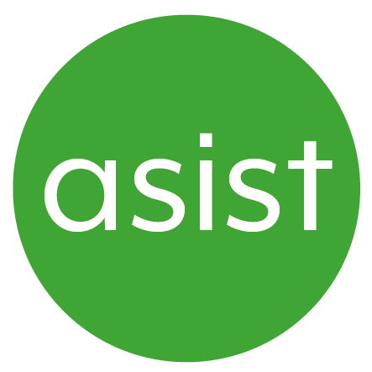
Independent NHS Complaints Advocacy
Referral form

To make a referral phone Asist on  01782 845584, fill in this form and send it to Asist using the address at the end of this form, or email referrals@asist.co.uk
Service available Monday to Friday 8.30am to 5pm (excluding bank holidays)
(Referrals can be made by anyone)

About You (or the person you are making this referral for)
Name: | Date of Birth:
First Line of Address: | Postcode:
Email: | Tel:

 |  | How does this person communicate?
Preferred Language: |  |  |  | Words/Pictures/Makaton
Spoken Language |  |  |  | Gestures/Facial Expressions / Vocalisation
British Sign Language |  |  |  | Unknown
Other, please give details:

About Your Concern or Complaint
A Hospital within the (University Hospital of North Midlands NHS Trust) |  | West Midlands Ambulance Service
GP Practice (Health Care Professional, Reception/administration staff) |  | SDUC out of hours GPs  (Staffordshire Doctors Urgent Care)
Mental Health Services Combined  Healthcare NHS Trust (Adult Inpatient,  Adult Community, other services) |  | Community Health & Health Centre  (Health Care Professionals, Reception/administration staff)
Name:

Additional Information
Please give details of any forthcoming meeting dates.

Please add your comments here (optional)
Please give brief account of incident and date of issue being complained about.

 | Referrer Contact Details (if you are making a referral for someone else)
Referrer’s Name:
Job Title: |  | Team:
Email: |  | Tel:
Date of referral:

Head Office; Asist, Winton House, Stoke Road, Stoke-on-Trent, ST4 2RW

